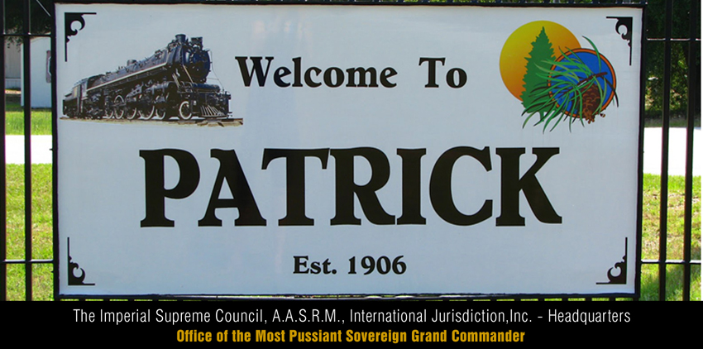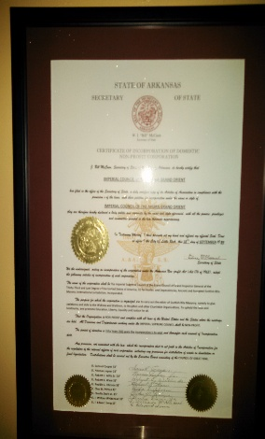

It is essential that we remain united, as our harmony and Masonic unity are crucial. If one group breaks-off from the rest, every group is affected and so, ultimately are our symbolic lodges. “The passion that incline men to peace, are fear of death; desire of such things as are necessary to commodious living; and a hope by their industry to obtain them. Reason suggests convenient articles of peace, upon men may be drawn to agreement. These articles, are they, which otherwise are called the Laws of Nature” –

The Idea of a Social Contract. (*T. Hobbes*,1651).

**Ill. Charlie Davis, Jr. 33°**  
**Most Puissant Sovereign Grand Commander**

**National & Internation Service Educational & Charitable Services Benevolence**

[](https://previews.123rf.com/images/lightwise/lightwise1310/lightwise131000063/22986371-helping-hand-with-a-shadow-on-pavement-of-an-adult-hand-offering-help-or-therapy-to-a-child-in-need-.jpg) [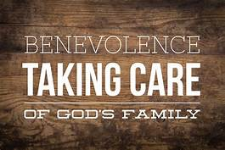](https://images.search.yahoo.com/images/view;_ylt=AwrJ6wpm4odcRFcAZq02nIlQ;_ylu=X3oDMTIzamlpbGpnBHNlYwNzcgRzbGsDaW1nBG9pZANmMGI5NDc5MTQ2YWY2ZjQ1NWYxMjhmMDI1MzY5YzRmYwRncG9zAzEwBGl0A2Jpbmc-?back=https://images.search.yahoo.com/yhs/search?p%3Dbenevolence%26fr%3Dyhs-pty-pty_maps%26hsimp%3Dyhs-pty_maps%26hspart%3Dpty%26tab%3Dorganic%26ri%3D10&w=2048&h=1365&imgurl=www.oak-hill.org/wp-content/uploads/2015/01/IMG_2870.png&rurl=http://www.oak-hill.org/benevolence/&size=6230.9KB&name=%3cb%3eBenevolence%3c/b%3e+%E2%80%93+Oak+Hill&p=benevolence&oid=f0b9479146af6f455f128f025369c4fc&fr2=&fr=yhs-pty-pty_maps&tt=%3cb%3eBenevolence%3c/b%3e+%E2%80%93+Oak+Hill&b=0&ni=128&no=10&ts=&tab=organic&sigr=114nehen3&sigb=13s91e8ui&sigi=11or09mag&sigt=10vq4o3jc&sign=10vq4o3jc&.crumb=J25LIqk6D2.&fr=yhs-pty-pty_maps&hsimp=yhs-pty_maps&hspart=pty)



The Imperial Supreme Council of the Ahura Grand Orient (hereafter referred to as Supreme Council) shall not engage business activities not permitted under IRC 501 (c)(8) and operate exclusively for charitable, religious, educational, and scientific purposes pursuant Section 501 (c)(3) of Internal Revenue Code of 1986.

The Supreme Council disseminates information and funds for scholarships awarded to eligible students and qualifying institutions pursuant to Art. VII of our Bylaws, Art. I, § 2, Art. II, § 1, applicable policies and procedures of the Supreme Council.

The social activities are a significant part of our fraternal society, but our organization recognition is not satisfied by the presence of social activities alone. The organization fraternal purpose involves and engages in fraternal activities. *See*. Philadelphia and Reading Relief Ass’n v. Comm’r, 4 B.T.A. 713 (1926). We perform civic, benevolent, and charitable (activities) as a part of our basic functions.